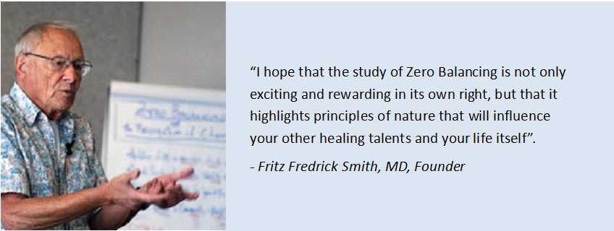

An exciting opportunity to study Zero Balancing in Derby.
Welcome to all who are inspired to step out on a journey of personal discovery and professional development.
This Core Zero Balancing (ZB) I/II workshop,
will be taught by Jo Hale
and will take place over two weekends,
February 2/3rd and 9/10th, 2019

Core ZB I & ZB II workshops present the theoretical insights and practical skills required to integrate body energy and body structure using conscious touch. These are invaluable to Health Care Practitioners and students of other disciplines, whether energy or structure is emphasized in their healing work.

Zero Balancing students are drawn from a broad range of health care disciplines. Students find that learning ZB significantly enhances the skill and effectiveness of their main modality, as well as being a valuable form of bodywork in its own right.

Non-healthcare practitioners studying Zero Balancing find that as well as learning a hands-on skill that they can practice with family and friends, their lives are enhanced in simply applying the principles that are taught during the course.

The number of participants attending each workshop is limited to ensure high levels of touch feedback. This workshop is part of the Zero Balancing Certification program (see www.zerobalaninguk.org )

Certified Zero Balancing Teachers have been trained by the founder of Zero Balancing, Fritz Frederick Smith MD (USA), and senior Zero Balancing teachers,
UK and International.
“It was a fantastic experience. I can highly recommend it to anyone, whether they want to go on and take the full Zero Balancing training or just develop for themselves and loved ones.”
SS Derby, Masseuse and Bodywork Teacher .

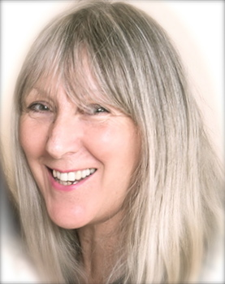 Please register for this course with Jo.
Home address: 11 Bank Buildings, Milford, DE560QJ

Course Fee - £420
Please send a deposit of £50 to secure your place.
The balance of £370 needs to be paid 2 weeks before the start date of the course.
Account details by request.

Course venue is Woodlands Natural Health Centre, Queen's Court, DE221GR

Teas/Coffee/Beverages/Biscuits will be provided.

Please wear soft and comfortable clothing.
You may need extra warmth and comfort whilst sitting.

Looking forward to seeing you all!

Kind regards,

Jo Hale

Dr. Jo Hale, D.RelCare (Health and Well-being)
Zero Balancing Faculty ZBAUK, Cert Zero Balancer
Homeopath, PGDip Homeopathy, PCH (Dynamis), RSHom
Home/business 01332 841939, Work 01332 299133 and Mobile 07534229275
johale@sky.com
http://www.woodlandsnaturalhealthcentre.co.uk/

